William Thomason

Joshua Price

Tyler Armstrong

Drew Hanson

3/1/2019

WEB-330

**Team Name**

**Right Between the Brackets**

**Team Captain**

**William T. Thomason**

**Meet the Team**

**William Thomason**

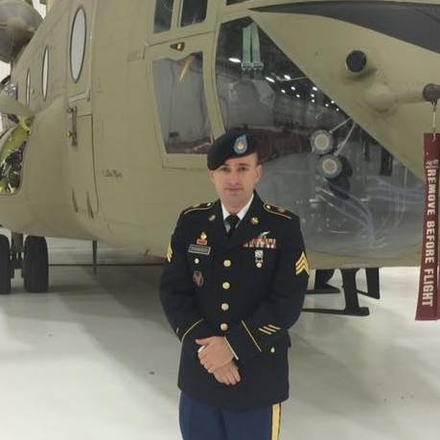

My name is William Tyson Thomason. I reside in Des Moines, Iowa with my wife and four children. I’m a member of the Iowa Army National Guard as a chinook helicopter mechanic. I have many interests such as fishing, hunting and camping. One of my passions is web development, I’ve been a freelance web developer for three years. I specialize in HTML, CSS and PHP. I have experience with multiple web frameworks such as Bootstrap, Laravel and jQuery with a firm understanding and some experience with Content management systems such as Drupal and WordPress. I have built and continue to maintain several websites for small businesses in the Des Moines area. I enjoy going to local user groups to meet other developers and to learn new things in the web development field. If there is one thing, I can say that I have learned about web development is that you never stop learning. I always strive to improve my skills and be the best developer I possibly can.

**Joshua Price**



I am Josh Price. I have worked in tech for five years now and am currently a System Administrator and do a lot of PowerShell Scripting. I’ve always loved the idea of being a developer but never did anything outside of a few online learning classes. Once I started working at my current company and now have the benefit of tuition reimbursement, I decided to attend Bellevue University and peruse my passion. Outside of that I am originally from Atlanta, GA and moved to Omaha almost four years ago. I love playing outside, going hiking, camping, biking, and take every opportunity I have not to be cooped up in the house. I am married and have one little one that keeps me busy at times, my wife is a Graphic Designer so she is always pushing me hard to make sure everything I work on is the best it can be. Also...ramen holds a special place in my heart.

**Tyler Armstrong**

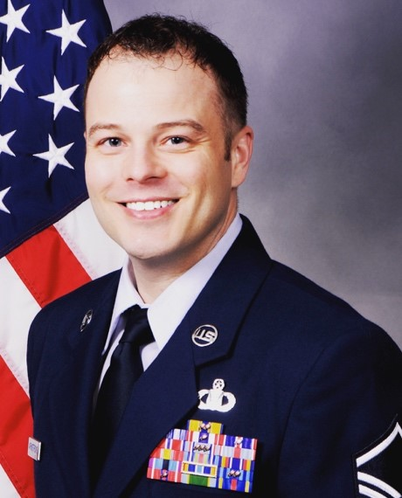

My name is Tyler Armstrong. I’m a single dad, and I’m originally from Lubbock, TX. I joined the Air Force in January of 2001. I have lived all over the United States and have traveled to many parts of the world. In 2014, I was selected for a special assignment to be a functional analyst and subject matter expert for the software we use to manage aviation resources in the Air Force. I managed Java developers and Oracle Database Administrators. I also oversaw all software testing, wrote tests in Unified Functional Testing (UFT), and led the requirements gathering process. During these four years, I earned my associate’s degree in Mobile Development from Full Sail University and taught myself the basics of HTML, JavaScript, CSS, and PHP to build WordPress websites as a hobby. I also have some experience with Node, Express, Pug, and MongoDB. After being introduced to web development, I quickly fell in love with it and withdrew from Full Sail University to enroll at Bellevue University to finish my B.S. in Full Stack Web Development. My goals are to retire from the Air Force in 2021, move closer to my daughter and begin my next career as a developer.

**Drew Hanson**



My name is Drew Hanson. I have a bachelor’s degree from University of Utah in Communication and Journalism. I am new at web development but enjoy learning the technique and skill on how to code. I am looking forward to completing my second bachelor’s from Bellevue University and working for a company that will utilize my past skills and my newly founded skills in a synchronized manner. A little personal note, I have been married for 8 years, I am a father of 3 bright and wonderful children. Some of my hobbies include most water sports; swimming and wake boarding are my favorite pass times. I prefer summer over winter and am excited for the temperatures to finally move out of winter into the warm summer months. I prefer Italian foods and key lime pie. I am more of a small-town guy than a city guy. My goal in life will be to have enough room available to have at least a few horses to roam around.

**Team Bio**

Our team is comprised of four developers (William, Tyler, Joshua, and Drew) who have varying levels of experience. Tyler and William have been working in web development and bring immense amount of knowledge and real work experience to the table. Although Joshua and Drew are new to web development, they bring a fresh perspective and ideas that have the potential to accelerate our team to the next level. Tyler and William are able to provide suggestions to Joshua and Drew for trouble shooting problems in code. Joshua and Drew are able to provide Tyler and William with ways to make the process less time consuming while learning from the more experienced members of the team. As each individual in the team is from different areas of the mid-west, we have proven out strong verbal and written communication skills to reach our goals. We do this by communicating via email daily.

**Application Description and Functionality**

The purpose of this application of to give the user a “quiz” and pose them with questions from our previous courses. We will be utilizing Bootstrap responsive grid framework to organize and have a base styling for this application. Bootstrap offers a wide array of prebuilt functionality that will really open the door for features and directions we can take this project. We will also be using HTML, CSS, JavaScript, jQuery and Knockout.js for implement the user interface as well as the back en functionality this application will offer to the user.

Our team is exploring a couple different options and features for this project that can define the overall final product. Our first option is to design our quiz in the form of a jeopardy game with five topics with questions assigned to these topics. Another option we have is to take a little more traditional quiz approach and display each question to the user one at a time.

We have a few features we are researching and would like to implement in this application. One feature is that we would like to ask for the users first and last name so that way we can display their name on the results page. This could be beneficial for the user if they need to print their results with their name associated with the quiz. Another feature we are looking into is setting and displaying a timer for the user to either answer each question or a timer to take the overall quiz. This will help prevent the user from just looking up the answers and get a better feel for their knowledge of the topics. We will most likely be utilizing pop up models to display the question to the user.